**JAVA FIRST PROGRAM:**

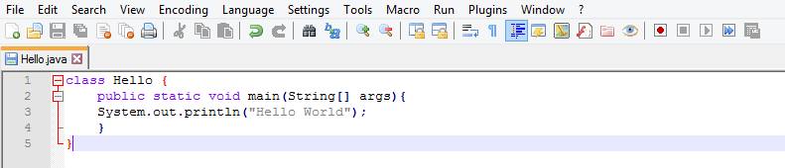

**Output:**

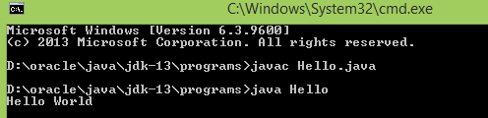

**FAQS:**

**Can we write java program by making class name and file name different?**

Yes. We can do. It is possible when we are using a normal or package class. We will get the .class file with the class name. but it is not recommended because every time we have to add the class name for execute the program.

Example:

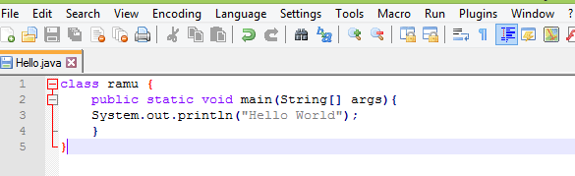

Here class name and file name both are different.

If I compile the above code, I will get ramu.class file.

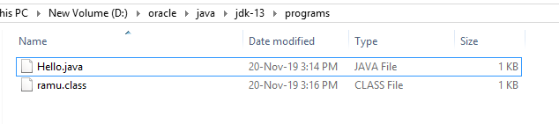

Now to execute we have to mention the .class file as ramu.

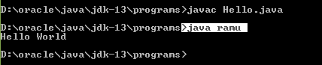

Let us consider following code.

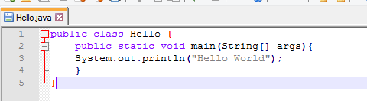

Here I have added a keyword public.

**Public:** with this we can access that class from anywhere in that machine.

**Package**: if public is not defined in the program, default it will take as package. With this we can access that class within the location where the code is present.

**Class:** Here class is a keyword it tells the compiler as “Hello“ is defined as a class.

**In which case file name and class name should be same?**

If we are using class name as a public. The first letter of class name and file name should be capital letter.

**How many classes can be written in single java program?**

Multiple classes can be written. As no. of classes are increased, the no. of .class files are also increased.

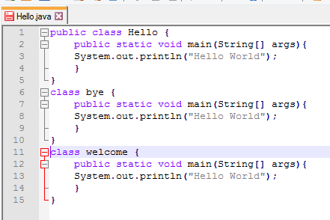

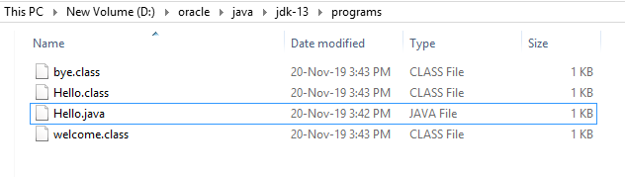

**How many public classes can be used in java program?**

We can use any no. of public classes in single java program. But we will get the compile time error. The ambiguity will happen. To overcome that error we have to use one or zero public class.

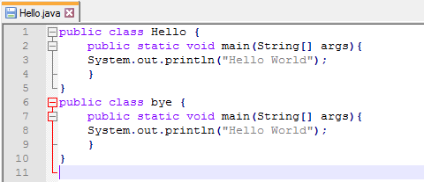

If I compile the above code following error will get.

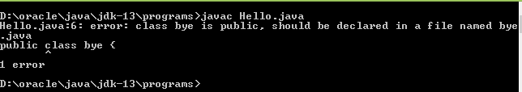

Let us consider the following example

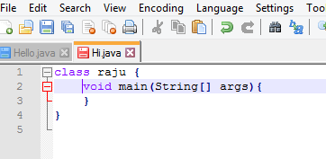

Now compile the code.



Here we did not get any compile time error even we are not adding logic and not adding “public static” keywords. Hence the compile will just check the rules and regulation and syntax. It will not check whether the code has logic or not.

But when we are executing the code, the JRE will give error.

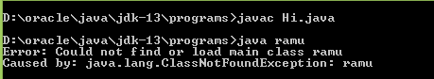

So for compilation main method is not required. But for running the program we must need main method as

“Public static void main(String[] args)”